KidsB
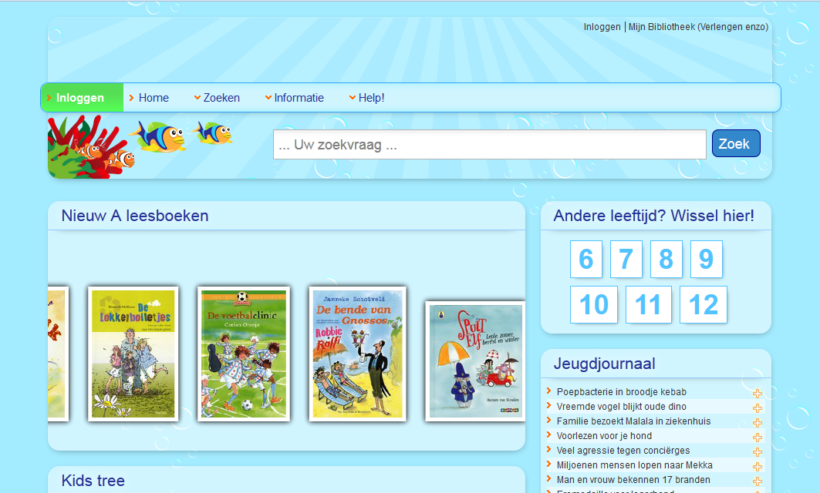

If you want the header like in the sample above. You can use this as the header source (in the site profile);
<div style="position:absolute; left:0; top:0;">
Replace me by a logo</div>
<div style="position:absolute; right:0; top:0;">
Replace me by a navigation</div>
<div style="position:absolute; right:0; bottom:0; margin:0 10px 20px auto;">
Replace me by a search</div>

The main menu links have two extra styles (green & red) to highlight items such as ‘Log-out’;
These can be activated by adding a custom class (warning / warningOK) to the navigation link.

To enable the widget styling we need to have some extra (spare) div’s in the widget’s code.
To enable the widget styling you need to check/edit 3 templates (in Structure&Style).
(Cat: vfocus.content)
ID;
- applicationcontainerregular
- applicationcontainernotitle
- applicationcontainerhiddentitle

Check if the Content has the spare divs.
If so, you’re ready to go!
If not;
- Copy the content to local content
- Replace this code at the end (only the last one): '</div>'
- by this code;
<div class='spare'><div class='spare1'><div></div></div><div class='spare2'><div class='sparea'></div><div class='spareb'></div></div><div class='spare3'><div></div></div></div>\n</div>
- Click ‘Save’

Different widget styles

You can choose the styling of each widget by adding a custom class to the widget.

These are the options for this theme;

coralleft
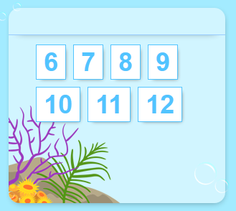

coralright
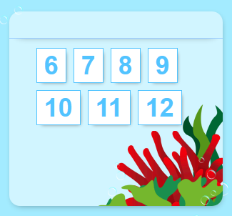

bedding
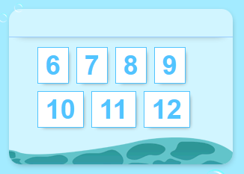

bubblesleft
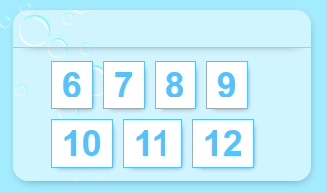

bubblesright
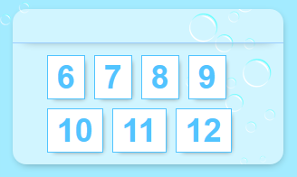

tentacles
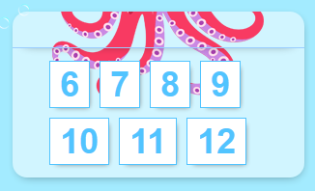

starfish
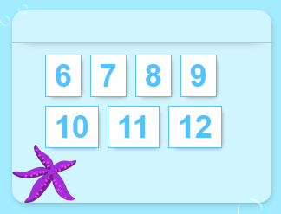

squid
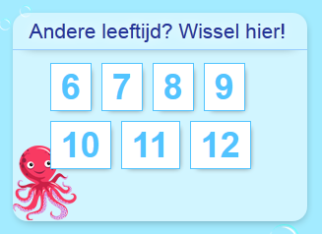

fish
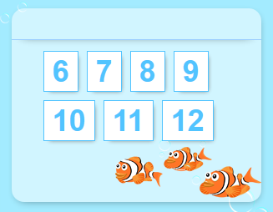

fish2
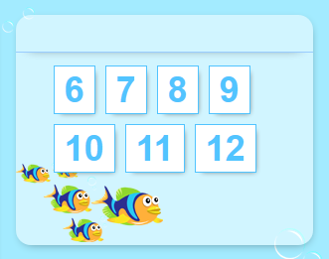

fish3
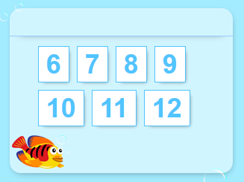

fish3right
