KidsC

Sample of the theme;
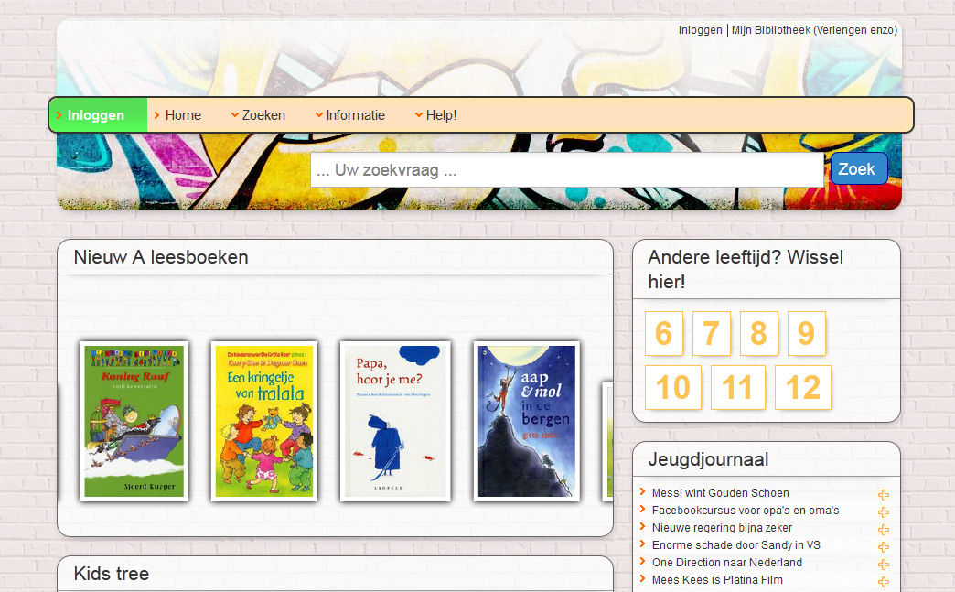

If you want the header like in the sample above. You can use this as the header source (in the site profile);
<div style="position:absolute; left:0; top:0;">
Replace me by a logo</div>
<div style="position:absolute; right:0; top:0;">
Replace me by a navigation</div>
<div style="position:absolute; right:0; bottom:0; margin:0 10px 20px auto;">
Replace me by a search</div>

The main menu links have two extra styles (green & red) to highlight items such as ‘Log-out’;
These can be activated by adding a custom class (warning / warningOK) to the navigation link.

